**Concordia Theatre chiefs set to ramp up child safety measures**

<http://www.hinckleytimes.net/news/local-news/hinckley-theatre-chiefs-set-ramp-6883937>

But police still critical of failure to act quicker to bolster protection following allegations of child sex abuse

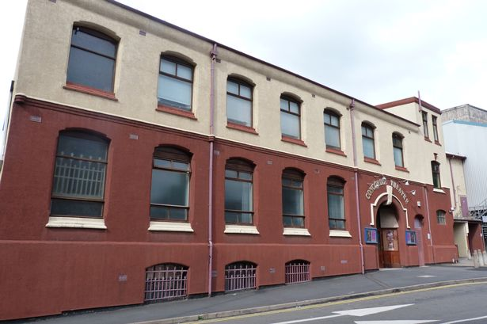

The Concordia Theatre

Child protection measures are to be ramped up at Hinckley’s Concordia Theatre following the underage sex abuse scandal which almost forced its closure.

The association which runs the Stockwell Head venue will strengthen safeguarding for young performers and volunteers after it was slammed by police for a string of child safety failings.

Leicestershire Police called for a licence review following investigations that revealed two former child sex offenders were working at the venue and another two men may have been involved in recent child sex offences - these men are on bail pending further inquiries.

Police say Concordia management hadn’t acted to bolster protection following these allegations, and the conviction last year of a performer for serious sexual offences involving children - most targeted through the theatre.

This led to both Leicestershire Police and Leicestershire County Council intervening and they have now forced the theatre to improve its child protection procedures and change key individuals who oversee safeguarding.

The improved regime has been ratified in an amendment to the association’s premises licence – which allows the theatre to put on public entertainment and sell alcohol. As a result, Leicestershire Police has agreed not to pursue a review of the licence at this time.

Last minute talks over the amendment halted Friday’s planned licence review where a three-man panel were set to look at five options for the Concordia’s future, including closure.

Detective Inspector Rich Hiom from Leicestershire Police is heading up Operation Goliath, the investigation into child sex offences at the venue, which has seen two men arrested and bailed and two others expelled from the theatre.

He said: “You have to bear in mind a chap was convicted of serious sexual offences against children back in June last year and nothing appeared to have changed since then.

“The safeguarding processes had not been reviewed and people with convictions of a sexual nature, even if they were historical, had been allowed to remain. This is not conducive to positive child protection.

“We as police have the prime consideration to ensure that children are safe so how could we allow this situation to continue. Our actions have been more than justified.”

Det Insp Hiom added while two of the men banned from the venue had child sex offence convictions from years back and pre-sex offender register days, a proper background check would have flagged up these crimes and action should have been taken.

“You just cannot allow people with criminal convictions of that nature to remain in a place where children and young people get undressed. Common sense has to prevail.”

Lack of co-operation from the theatre management had forced the review call but following the announcement talks had progressed significantly and mutually acceptable measures had been agreed.

Det Insp Hiom said: “The measures will reduce the chances that children will come to harm while at the theatre. However, it is important that parents and other adults remain vigilant for signs of grooming or abuse at any club or organisation including Hinckley’s Concordia Theatre.”

The conditions were devised following an investigation into safeguarding at the theatre. Compliance will be monitored by Leicestershire Police and Leicestershire County Council, who will consider requesting a further review if the conditions are not met.

Det Insp Hiom added the theatre would remain under the microscope even with beefed up safeguarding procedures in place. “The key thing is these measure need to be in place by May. It was a massive step to call the review - it could have closed the theatre down - and likewise it was a massive step to withdraw the review so significant progress has been made.

“But if it comes to May 2 and these conditions do not come to fruition we have the option of calling for a review once again and the situation is not over and done with.”

The new safeguarding committee members and officers will need to be approved by the police and Leicestershire County Council will not resume issuing child performance licences or letters of exemption - effectively meaning no child will be allowed to perform on stage - until the approved safeguarding policy comes into effect and all are assured it is being properly implemented.

Lesley Hagger, director for children and family services at Leicestershire County Council, said: “We’re pleased the Concordia has agreed to bring in a much more rigorous approach to child protection and the theatre is working with us to resolve the situation.

“Keeping young people safe remains our priority and we will work with the police to carefully monitor the revised conditions being adopted.

“Acting, singing and dancing clearly have a positive impact on young people’s wellbeing and when we’re satisfied the new procedures are in place we will end our freeze on performance licences and exemptions.”

A spokesman from the Hinckley Concordia Theatre said: “We have worked very closely with all of the relevant stakeholders – including Leicestershire Police and Leicestershire County Council – to put in place a much more robust set of child protection measures in line with their advice and guidance.

“We are pleased the authorities have recognised the work we have undertaken and we will continue to liaise closely with them to ensure the Concordia Theatre remains a safe environment for all.”

The theatre’s new conditions include:

* The adoption of a new comprehensive safeguarding policy, to be approved by police and Leicestershire County Council, to be in place by May 2, 2014

* A system of vetting trustees, performers and volunteers

* The use of enhanced disclosure and barring service checks (previously known as criminal records bureau checks) where appropriate

* The appointment of a new safeguarding committee

* Improvements to the theatre’s CCTV system, continuing to make recordings available to police upon request