**MAIL ONLINE**

**TV talent shows will need a licence to put children in 'contrived situations for dramatic effect'**

* **Concerns raised last month after nine-year-old Malakai Paul started crying on Britain's Got Talent**
* **Rules children performing on TV, radio, film or in the theatre were last reformed in 1968**
* **They are outdated, complex, confusing and not fit for purpose, says Children's Minister**

By [Anthony Bond](http://www.dailymail.co.uk/home/search.html?s=&authornamef=Anthony+Bond+)

Television talent shows will be forced to apply for licences to feature child stars to protect them from producers who want to 'push the boundaries'.

The biggest shake-up of performance rules for 40 years was ordered by ministers amid concerns that the current regulations are 'archaic, complex and irrelevant'.

Proposals published today - whoch also cover reality TVs hows - say that producers will be expected to gain a licence if a child is going to be put in an 'artificial situation, which may have been contrived for artistic, editorial or dramatic effect'.

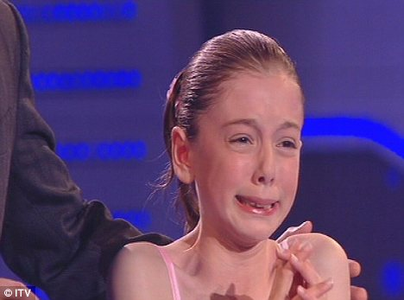

Changes: TV talent shows will be forced to apply for licences to feature child stars under new proposals. Britain's Got Talent was criticised three years ago when Hollie Steel, pictured, started crying after struggling to complete a song

This includes programmes that are billed as observational or factual, but actually put a child into a contrived situation.

Rules on including children in performances, including TV, radio, film or theatre, were last reformed in 1968 - a time when there were just three television channels and a small number of radio stations.

Those rules stated that a licence was needed for under-14s who would be singing, dancing, acting or taking part in musical performances.

But there have been suggestions that this left a grey area between factual programming and entertainment shows that is not covered by the rules, and has left some producers unsure if they need a licence.

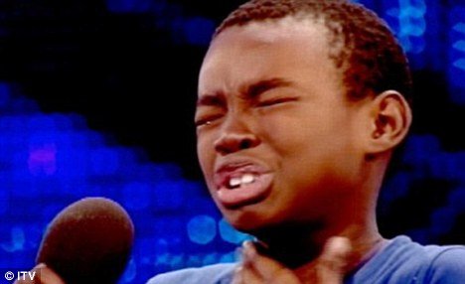

Worry: Last month, the Children's Minister Sarah Teather voiced concern after Malakai Paul, 9, pictured, broke down in tears while singing for the judges on Britain's Got Talent

In the modern age, the rules are unclear and no longer fit for purpose, ministers suggested.

Children's Minister Sarah Teather raised concerns last month after Malakai Paul, 9, started crying while singing for the judges on Britain's Got Talent.

The show was also criticised three years ago when Hollie Steel started crying after struggling to complete a song.

Children's Minister Tim Loughton said: 'We want to nurture not just the big stars of the future but help all children realise their talents by being able to perform.

'Everyone should have the chance to act, sing, dance and play sport - giving them memories for life.

'The current rules get in the way of that. They are outdated, complex, confusing and not fit for purpose.

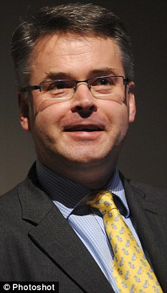

New proposals: Children's Minister Tim Loughton, pictured, said current rules are outdated, complex, confusing and not fit for purpose

'They come from an age when there were just three television channels and bear no relation to the broadcasting or performing industries in the 21st century.

'The rules are incredibly complex, bureaucratic and patchily applied - meaning that many amateur dramatic groups simply do not involve children in their plans, which is ridiculous.'

The proposals say that a parent must take responsibility for their child's activities, and producers will have to show they have strong safeguarding measures in place before they apply for a licence.

Under the last Labour government, then schools secretary Ed Balls ordered a review of child performance rules amid fears that youngsters were being exploited by reality TV.

At the time, Mr Balls said he was not attempting to stop children from appearing on talent shows, on stage or in documentaries.

But he added there were concerns that some programme makers were determined to 'push the boundaries' to provide a shock value and push up ratings.

His review was ordered shortly after concerns were raised about the Channel 4's 2009 show Boys And Girls Alone, in which a group of 20 children aged eight to 11 were left to their own devices in isolated cottages in Cornwall.

Read more: <http://www.dailymail.co.uk/news/article-2149685/Britains-Got-Talent-need-license-children-perform.html#ixzz1w4hpElxj>